The VTTA Surrey/Sussex Group
Open 25 MILE TIME TRIAL on Sunday 17th September 2023
Promoted for and on behalf of Cycling Time Trials
under their rules and regulations.
- START SHEET -

Event secretary  Andy Critchlow (Paceline RT)  Rose Cottage, Cockshot Hill,  Reigate, Surrey. RH2 8AN  Email: andycritchlow@me.com  Mobile: 07970352994 | *** Event Headquarters ***  Fairwarp Village Hall,  Nursery Lane, Fairwarp,  East Sussex. TN22 3BD  On CTT Course no. G25/89 | Timekeeper & Recorder  Su Balcombe  (Brighton Excelsior CC)  &  Peter Moon  (Eastbourne Rovers)

PRIZE VALUES

For veterans with the best plus on the current VTTA standard times:
1st - £15 2nd - £10 3rd - £5 Fastest female Vet on standard: £15

The ROBIN BUCHAN TROPHY will be awarded to the first member of the Surrey/Sussex Group on standard.
The POUND HILL TROPHY to be awarded to the first Club team of 3 Surrey/Sussex Group members on standard.
The 3 winning team members will also be awarded VTTA medals.

Fastest time overall: 1st - £15 2nd - £10 Fastest female rider: £15
One rider, one prize.

The VTTA trophies and medals will be awarded at the Surrey/Sussex Group’s lunch on Feb 6th 2022
at The Normandy Centre, Denne Road, Horsham RH12 1JF and it is hoped that the winners will be able to attend.

Please note the following points :

- Numbers will be available at the HQ which will be open from 7:15am. You must sign on before collecting your number and note the details of any special hazards on the course which will be displayed there (see specific COVID-19 guidelines below).
- You must also now sign out when returning your number after your ride. Fail to do so and you will be shown as DNF
- London South District regulation - No vehicles, except those of the timekeepers and event officials, shall be parked in the vicinity of the starting and finishing areas.
- Competitors are requested not to warm up on any part of the course after the first rider has started.
- Riders must not cross the A22 in the vicinity of the start and finish areas.
- There are a number of roundabouts on the course and riders must exercise extra care, giving way to traffic from the right.
- No times given at the finish or HQ.
- CTT regulations require the compulsory use of a protective cycle helmet by riders aged under 18 in time trials. In the interests of your own safety Cycling Time Trials and the event promoters strongly advise all competitors to wear a hard/soft shell cycle helmet that meets internationally accepted safety standards.
- Working rear and front lights, either flashing or constant, should be fitted to your cycle in a position where it is clearly visible to following road users and is switched on for the duration of your ride in the event.
- Responsibility for taking the correct route rests with each rider, so please read the course details. Where marshals are positioned on the course they indicate the direction to be taken by riders but do not control the flow of traffic or indicate that it is safe for the rider to proceed. Please take care whilst riding and avoid becoming another accident statistic.
- Please only park at village hall.
CAR PARKING
There is only limited space for cars to park in the area in front of Fairwarp Village Hall.
Once this is full please only park on the left-hand side of Nursery Lane beyond the Hall and do not park in or obstruct the track which goes straight ahead at the right-hand bend. You can use the verge on the left-hand side of the road after the bend for additional parking. Do not do anything which might annoy the local residents as our future use of the Village Hall for the HQ is at risk if we get complaints. receve.

The VTTA Surrey/Sussex Group hope that you keep your head up and enjoy a safe ride.
If you are aged over 40 and are not already a member of the VTTA please consider joining
–the Event Secretary would be pleased to provide you with details or you can visit the VTTA website.

COVID Specific Requirements
- A full CTT Risk Asessment can be found at the following location (https://www.cyclingtimetrials.org.uk/documents/download/7836), riders should familiarise themselves with the document and any riders displaying covid symptoms must not attend this event
- The HQ has been provided for parking, changing and toilet purposes only
- Riders must be respectful of social distance conventions and hygiene expectations.
- Riders are encouraged to socialise in the outdoor areas of the HQ where possible.

Course map

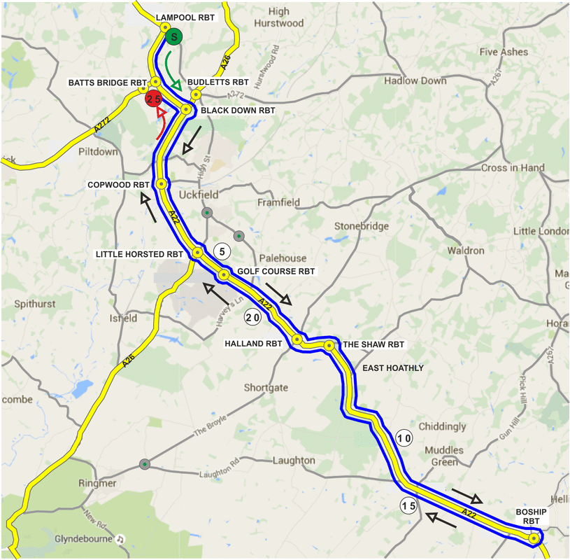

NUMBERS MUST BE FIXED BELOW WAIST
YOU ARE ALSO ADVISED NOT TO RIDE IN DARK CLOTHING

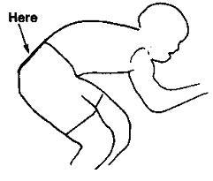

NO TIME MAY BE RECORDED IF NUMBER IS NOT CORRECTLY POSITIONED.

RIDE WITH YOUR HEAD UP!!!

